Linked List

What is a Linked List?
A linked list is a sequence of nodes in which each node is made up of two parts:
- Data: The value stored in the node.
- Pointer: A reference to the next node in the sequence.

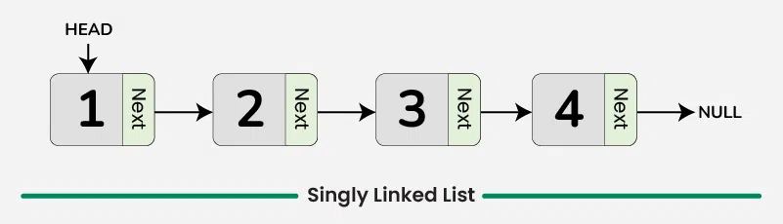

#include <stdio.h>
#include <stdlib.h>

struct Node {
int data;
struct Node* next;
};

struct Node* createNode(int data) {
struct Node* newNode = (struct Node*)malloc(sizeof(struct Node));
newNode->data = data;
newNode->next = NULL;
return newNode;
}

void insertAtFirst(struct Node** head, int data) {
struct Node* newNode = createNode(data);
newNode->next = *head;
*head = newNode;
}

void insertAtEnd(struct Node** head, int data) {
struct Node* newNode = createNode(data);
if (*head == NULL) {
*head = newNode;
return;
}
struct Node* temp = *head;
while (temp->next != NULL) {
temp = temp->next;
}
temp->next = newNode;
}

void insertAtPosition(struct Node** head, int data, int position) {
if (position == 0) {
insertAtFirst(head, data);
return;
}

struct Node* temp = *head;
for (int i = 0; temp != NULL && i < position - 1; i++) {
temp = temp->next;
}

if (temp == NULL) {
printf("Position out of range\n");
return;
}

struct Node* newNode = createNode(data);
newNode->next = temp->next;
temp->next = newNode;
}

void printList(struct Node* head) {
struct Node* temp = head;
while (temp != NULL) {
printf("%d -> ", temp->data);
temp = temp->next;
}
printf("NULL\n");
}

int main() {
struct Node* head = NULL;

insertAtFirst(&head, 10);
insertAtEnd(&head, 20);
insertAtEnd(&head, 30);
insertAtPosition(&head, 15, 2);

printf("Linked List: ");
printList(head);

return 0;
}

